Application of Geodesign to Impact Assessment in Japanese PFM

1. Introduction
Public facility management is one of the most arrestive social issue in Japan (MIC, 2014). In 1960s to 1970s, a lot of public facilities were built in the urban areas of Japan because of the alarming economic growth and population concentration. On the other hand, since those facilities were architected based on previous building standards law, they are not satisfying the current standard for building.
In this situation, some local governments have started planning to rebuild them but there are mainly two limitations (Nemoto, 2011). The first is the change of public facilities’ needs. The existing research is explaining that Japanese population will decrease in this century and highly aged society will come in near future. Second is the limitation of municipal budget. Because of the huge amount of deteriorated public facilities, it is obviously impossible for each municipality to rebuild all of them not only in short term but also in long term. Hence, planning approach (or so-called “triage” methodology) is seemed to be essential to promote public facility rebuilding and management effectively.
The existing research about Japanese public facilities management are mainly focusing on economic rationality. On the other hand, public facility management includes decommissioning and reduction of the part of facilities and it can be thought as the cause of social impact to the area. It means the importance of planning approach in public facility management through environmental, economical, and social impact assessment. In this paper, “sustainability assessment” means the integrated impact assessment among environmental, economical, and social impact factors (Harashina, 2015).
This paper aims to develop the theoretical framework of sustainability assessment in public facility management. Especially “geodesign” approach is focused on in this paper as a effective factor to promote communication between the stakeholders and decision making of public facility management through sustainability assessment process.

2. Characteristics of Geodesign in IA Context
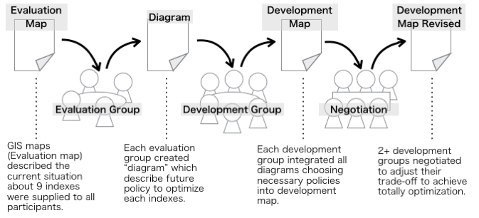
Impact assessment is an application of systems analysis for decision making and it requires comparison among some alternatives with the respect to various indexes. Harashina (2000) suggest two major communication methodology to satisfy the condition of impact assessment as above –document based communication and meeting based communication. Harashina set the goal of them to keep transparency of the assessment and decision-making process.
Fig. 1 Summary of Geodesign Workshop in Yosano Town Public Facility Management Process
On the other hand, especially integrative impact assessment such as sustainability assessment requires the validity of integration of various alternatives. This paper focus on a communicative methodology named “Geodesign” as a solution of this problem.
The decision-making method “geodesign” has been developed and discussed by Dr. Carl Steinitz’s research group, and in some municipalities, there are some application cases all over the world (Nyerges et. al., 2016) including Japan.
In this paper, communication in geodsign will be analyzed through a case study in Yosano town public facility management in Japan.

3. Obstacles for Application of Geodesign to Impact Assessment Process

3.1. Yosano town Geodesign WS
Yosano town is in the central region (Kinki Region) of Japan along Sea of Japan and is facing population decreasing and aging society. Yosano town is making the grand vision (Master Plan) including public facilities management and planning to apply the geodesign methodology to planning process.
To conduct Yosano town’s geodesign, “Geodesign Workshop” was held for 3 days. This workshop included 1 day fieldwork in Yosano town and 2 days discussion. 25 scientists participated to the WS and they were mainly young researchers such as PDs, Ph. D students, and master-course students.
The process of the WS was expressed in Fig. 1. In the WS, 3 kinds of GIS map were supplied and created and 3 kinds of communication (evaluation group, development group, and negotiation) were held to assess the impact to environment, economy, and society by each plan (GIS map) and integrate the various GIS maps.

3.2. Hypothesis of Obstacle for Geodesign Application
In this paper, the question “What is strength and limitation of Geodesign in IA process?” will be discussed. The methodology of geodesign is scientific and communicative, hence it will have a high affinity with impact assessment process to satisfy scientific aspect and democratic aspect of IA. On the other hand, there will be some kinds of difficulties in application of geodesign methodology to impact assessment such as;
- [resource and time limitation] geodesign is a communication process among scientists hence it is important to keep the balance between gathering various kind of scientists to guarantee the quality of communication and budget and time limitation,
- [information understandings] Impact assessment obviously requires current situation of environment, economy, and society in the project site, and because geodesign process based on the information expressed by GIS. This can be one of the greatest strength of geodesign application to IA process, but it is also important to share such information among scientists correctly and sufficiently through the effective process design.
- [communication] Impact assessment with geodesign methodology includes communicative process among scientists. It can be effective to make decision based on integration of various alternatives through communication process, but it will be process design problem to make adequate environment to make scientists’ communication effective and correct.

3.3. Research Method
To consider of the obstacles for geodesign application as above, the datum of the participants’ recognition to Yosano town Geodesign WS was collected by the questionnaire survey and interview. Questionnaire survey was consisted of mainly 4 sections; A) understanding of GIS maps, B) understanding of Yosano town’s condition, C) difficulty of the groupworks and negotiations, and D) the topic which the respondents wanted to discuss if there had been more time in WS.

4. Analysis of Participants’ Recognition –Considering of Three Research Questions
[Could the participants discuss and negotiate about their opinion based on the various criterion?] – Three types of group work and three types of inter-group negotiation were held in the workshop. The members in each group discussed and made the GIS map based on their own theme while the backgrounds of them were different among each other. In addition, the working groups could change or adjust their plan on the GIS maps through the negotiation process. Hence, three questions about the participants’ recognition can be extracted.

4.1. Communication in the WS
The first question is about difficulty of communication in the group work and the negotiation. The group work member had their own different background and there were not small gaps of the understanding of Yosano town policy, geological condition, socio-economical condition and so on. It can be one of the question “Did the backgrounds and knowledge difference affect the participants’ recognition about the close communication in the work shop?”
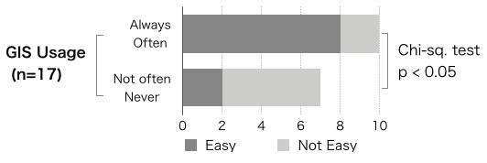
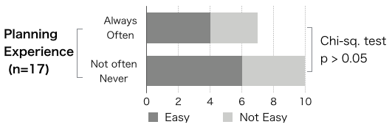
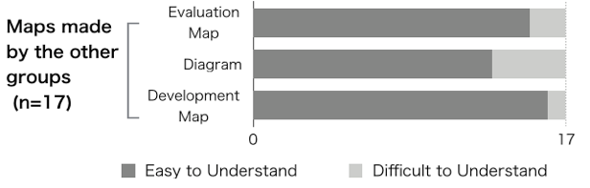
Fig. 2 and Fig. 3 are the descriptions of the participants’ recognition about inter-group negotiations (Easy / Not Easy). According to the bar chart in Fig. 2, there is a statistically significant difference of negotiation recognition between “GIS experienced group” and “not GIS experienced group”. On the other hand, there cannot be seen the significant difference between “Planning experienced group” and “not Planning experienced group” (Fig. 3).
Fig. 2 Comparison of Participants’ Recognition of Inter-group Negotiation with the respect to GIS usage
Fig. 3 Comparison of Participants’ Recognition of Inter-group Negotiation with the respect to Planning Experience
Fig. 4 Participants’ Recognition of Difficulty to understand the GIS maps made by the other groups
It is obviously important to gather sufficiently skilled participants to geodesign-based impact assessment to make, analyze, and revise the GIS map, and these questionnaire result indicates the important role of GIS skill in geodesign-based impact assessment to effectively integrate the maps through the inter-group negotiations and integrate the results of impact assessment by each group.

4.2. Understanding of GIS maps
The third is about difficulty of understanding of GIS maps made by the other groups. In the group works and the negotiations, discussions and works were processed based on the GIS maps made by the other participants. On each GIS map, there were describes the legend about all expressions, but there were not only the name of area and buildings but also wide area development and planning horizon. Hence the GIS map were complicated to understand the correct meaning. Then, a question that “Did the difference of GIS maps understanding affect the participants’ recognition?” can be extracted.
From the questionnaire survey, there are greater answer “easy for me” to understand the evaluation map, diagram, and development map made by the other groups (Fig. 4), but some respondents pointed of the problem in the work shop process for example “the labels and the legends in GIS map was difficult to understand because there were little explanations about their meaning by the map developers”. Hence, the importance of communication among scientists in this kind of workshop has been suggested to process impact assessment based on sufficient understanding of the all works from the any viewpoint.

4.3. Role of the scientists in impact assessment
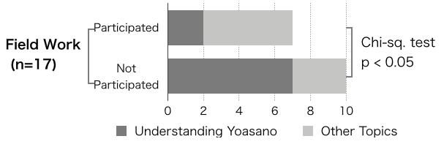
The fourth is about the limitation of the participants’ understanding about Yosano town. As explained in chapter 2, participation of scientists in impact assessment process is necessary and important, but Geodesign is an activity based on participants’ GIS skills and understanding of local environment, culture, industry, and human activity in the planning area. Hence, the question “Could the participants assess the social, environmental, and economic impact based on sufficient understandings about Yosano town?” should be important to consider the strength and limitation of Geodesign application to impact assessment process.
Fig. 5 Comparison of Participants’ Recognition of the most important topic for Geodesign Application to Impact Assessment
Fig. 5 is a comparative bar chart about which topic had to be discussed or informed in this workshop if there were more time. In this graph, the rate of respondents who answered “time must be spared to share the information about Yosano town” in “Field work participants” group is significantly less than the other group. Therefore, field work activity took the major part to share the information of Yosano town and it is pointing out the importance of information gathering activity as a preparation for Geodesign by scientists.
On the other hand, impact assessment is an assistive tool for sustainable decision making as explained in chapter 2. Hence, there should be not only preparative activity between scientists and local stakeholders but also interactive activity among them to conduct assessment based on sufficient information, scientific methodology, and democratic process. Some participants suggested in the final part of the questionnaire “Geodesign methodology will take more part if there is more interactive process between the Geodesign workshop participants, the public officers, and the citizens in Yosano town”. Geodesign application to impact assessment process is one of the powerful method to integrate various alternatives but preparative and interactive process with local stakeholders should be added as supplemental process of geodesign approach’s limitation.

5. Conclusion
Through this participants’ recognition analysis, strength and limitation of Geodesign in IA process has been clarified. First, communicative process in geodesign can be a major strength to apply to impact assessment process, but it is important to consider of the GIS experience gap among participants. Next, by sparing sufficient time to share GIS maps, participants can discuss and integrate the various alternatives through communication process. Finally, needs of interactive process between local stakeholders and scientists to keep correctness of information. This is a limitation of geodesign application to impact assessment process.

